Article of The Week #3
1. ​Survey​ the text
2. ​Read​ closely and show evidence by ​CODING THE TEXT. I=Interesting,?=Question, *=Important,!=Surprising A=Agree, D=Disagree, C=Connects to something else I know.​
3. Look up ​vocabulary ​to clarify understanding
4. Write an objective summary
5. Choose one ​reflection

Mets fans find it’s cheaper to fly to Missouri to see World Series than at Citi Field
BY CHRIS SOMMERFELDT, LARRY MCSHANE NEW YORK DAILY NEWS Saturday, October 24, 2015, 8:14 PM

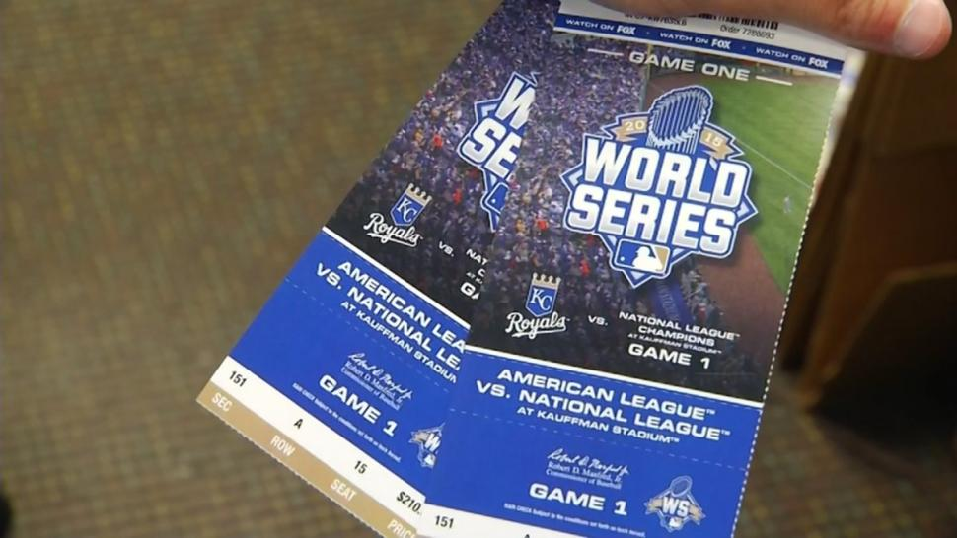

According to figures from TiqIQ, Game 3 in New York is $1,578.28 and Game 4 is $1,587.95.

Kansas City, here they come.
Mets fans suffering sticker shock from the $1,600 average resale price of a World Series seat for Citi Field instead pondered plans Saturday to head west for the first two games at Kauffman Stadium.
“Over there, it’s just so much cheaper,” said Mets die-hard Fernando Pacheco, 35, of Queens. “I have a buddy over in Kansas, too, so I would have it all set up.”
The Navy veteran, who just returned from deployment in Bahrain, needed the one thing money can’t buy: “A good excuse for getting out of work.”
A quick Daily News analysis found a thrifty Mets fan could spend less than the Citi Field one-seat average price for a one-game visit to Kansas City.
To fly round-trip out of LaGuardia Airport, buy the cheapest StubHub seat at $358 and crash for one night in a K.C. motel would run just over $800 — a postseason bargain.

StubHub reports that one Mets fan paid the truly Amazin’ price of $11,000 apiece for four seats to Game 3 in Queens — the highest figure so far in either ballpark.
And the World Series is shaping up as the most expensive ever, with an average ticket price of $1,539.51.
The National League champion Mets open their series with the Royals on Tuesday night as a pair of ’60s expansion franchises fight for the 2015 title.
Keith Vasquez, 26, discussed taking an 18-hour car ride to Kansas City with some friends after realizing the Citi Field seats were simply too expensive.
“Because I work, maybe I can’t do it,” he said. “I want to see the Mets, though. Mets in the World Series — I have to see it. Fifteen years. It’s been way too long.”
The Metropolitans, who lost to crosstown rivals the Yankees in 2000, last won the series in 1986.

Lifelong Mets fan Edgar Alsina, 62, of Yonkers, broached the idea of a road trip with his wife Saturday morning. After buying a $42 Mets World Series cap at the Citi Field store, Alsina imagined wearing his new lid at the first game.
“I think we can kill them in five games,” predicted Alsina. “I’m going home right now to check the prices. It’s possible. I have to watch my team. I can do it. I know I can do it.”
According to figures from TiqIQ, a ticket aggregator, the average price of a ticket for Game 1 in Kansas City is $1,244.27 and Game 2 is $1,198.12.
Game 3 in New York is $1,578.28 and Game 4 is $1,587.95. The Mets would also host Game 5 of the series if neither team sweeps.
The average price of tickets on StubHub was $830 for Game 1 in Kansas City and $1,116 for Game 3 in Queens. The cheapest seat for the opener is $358, while the cheapest seat for the first game in Queens is $499.
The Royals won their second straight American League pennant with a thrilling 4-3 victory Friday night over the Toronto Blue Jays. Their only World Series title came in 1985.
Rikers Island correction officer Hector Roman said he will put in for time off — and spring for the ticket price — if the series goes six games.
The last two games in the best-of-seven series are set for Kansas City.

“They give more love to the fans if they see us in another city,” Roman, 32, of the Bronx said of the potential road trip.
Mark Kramer, 48, of Long Island, has tickets for one of the games in Queens but is still contemplating a trip to Missouri.
“I might consider going to Kansas City, too,” he said. “I’m going to look online. It’s the Mets in the World Series. It’s like a lunar eclipse.”
lmcshane@nydailynews.com

